# 1. Consider the logic gate circuit shown below (5 points)

1. (2 points) Derive a Boolean equation for the output X
$$\overline{\overline{(\left(A⊕C\right)}+\overline{B})} \overline{(\overline{B}(B+D))}$$

2. (3 points) Draw a truth table for the circuit

|  |  |  |  |  |  |
| --- | --- | --- | --- | --- | --- |
| # | A | B | C | D | X |
| 0 | 0 | 0 | 0 | 0 | 0 |
| 1 | 0 | 0 | 0 | 1 | 0 |
| 2 | 0 | 0 | 1 | 0 | 0 |
| 3 | 0 | 0 | 1 | 1 | 0 |
| 4 | 0 | 1 | 0 | 0 | 0 |
| 5 | 0 | 1 | 0 | 1 | 0 |
| 6 | 0 | 1 | 1 | 0 | **1** |
| 7 | 0 | 1 | 1 | 1 | **1** |
| 8 | 1 | 0 | 0 | 0 | 0 |
| 9 | 1 | 0 | 0 | 1 | 0 |
| A | 1 | 0 | 1 | 0 | 0 |
| B | 1 | 0 | 1 | 1 | 0 |
| C | 1 | 1 | 0 | 0 | **1** |
| D | 1 | 1 | 0 | 1 | **1** |
| E | 1 | 1 | 1 | 0 | 0 |
| F | 1 | 1 | 1 | 1 | 0 |

# 2. Introduction to Logisim (3 points)

This question will introduce you to Logisim – a graphical tool for designing and  simulating logic circuit/system

After finish all the steps, you should have a circuit file. **Save the circuit file and submit it**.

# 3. (14 points) Design a combinational circuit system.

Design a combinational circuit with three inputs x,y,z, and three outputs A,B,C. When the binary inputs is 0,1,2,or 3, the binary output is two greater than the input. When the binary input is 4,5,6,or 7, the binary output is one less than the input.

Please answer all of the following sub-questions.

1. (3 points) x,y,z are inputs and A,B,C are outputs. Draw a truth table for the given function.

|  |  |  |  |  |  |
| --- | --- | --- | --- | --- | --- |
| X | Y | Z | A | B | C |
| 0 | 0 | 0 | 0 | 1 | 0 |
| 0 | 0 | 1 | 0 | 1 | 1 |
| 0 | 1 | 0 | 1 | 0 | 0 |
| 0 | 1 | 1 | 1 | 0 | 1 |
| 1 | 0 | 0 | 0 | 1 | 1 |
| 1 | 0 | 1 | 1 | 0 | 0 |
| 1 | 1 | 0 | 1 | 0 | 1 |
| 1 | 1 | 1 | 1 | 1 | 0 |

1. (3 points) Based on the truth table you draw, build Karnaugh maps for the output A,B,C.

|  |  |  |  |  |
| --- | --- | --- | --- | --- |
| A | $$\overline{x}\overline{y}$$ | $$\overline{x}y$$ | $$xy$$ | $$x\overline{y}$$ |
| $$\overline{z}$$ |  | 1 | 1 |  |
| $$z$$ |  | 1 | 1 | 1 |

|  |  |  |  |  |
| --- | --- | --- | --- | --- |
| B | $$\overline{x}\overline{y}$$ | $$\overline{x}y$$ | $$xy$$ | $$x\overline{y}$$ |
| $$\overline{z}$$ | 1 |  |  | 1 |
| $$z$$ | 1 |  | 1 |  |

|  |  |  |  |  |
| --- | --- | --- | --- | --- |
| C | $$\overline{x}\overline{y}$$ | $$\overline{x}y$$ | $$xy$$ | $$x\overline{y}$$ |
| $$\overline{z}$$ |  |  | 1 | 1 |
| $$z$$ | 1 | 1 |  |  |

1. (3 points) Derive (as simple as possible) Boolean equations for A,B,C using the Karnaugh maps

A = Y + XZ

B = ~X~Y+XYZ+~Y~Z

C = X~Z+~XZ

1. (3 points) Based on the Boolean equations, draw the logical gate diagram (circuit) for this system in Logisim. Attach the circuit file and image.

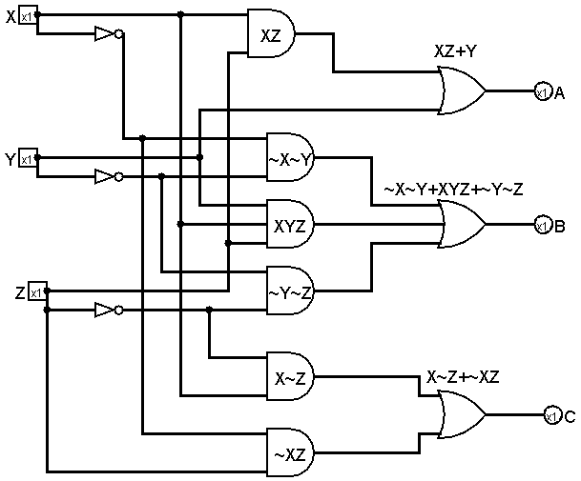

1. (2 points) Test your circuit with the Logisim simulation and generate the truth table (In logisim, project-->analyze circuit-->table), and copy & past the table here.

